Biden's infrastructure czar urges governors to appoint their own infrastructure implementation coordinators

By Kate Sullivan, CNN
Updated 1:00 PM ET, Tue January 4, 2022
https://www.cnn.com/2022/01/04/politics/mitch-landrieu-letter-to-governors-infrastructure/index.html

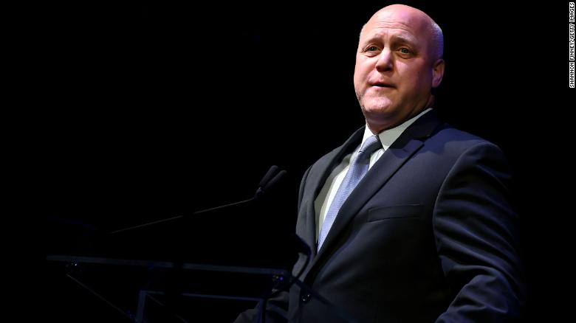
WASHINGTON, DC - DECEMBER 03: Former Mayor of New Orleans Mitch Landrieu delivers remarks during the 2019 Herbie Hancock Institute of Jazz International Guitar Competition at the Kennedy Center Eisenhower Theater on December 3, 2019 in Washington, DC. (Photo by Shannon Finney/Getty Images for Herbie Hancock Institute of Jazz)

(CNN) President Joe Biden's infrastructure czar Mitch Landrieu sent letters to all the nation's governors on Tuesday urging them to appoint their own infrastructure implementation coordinators to smooth the rollout of the $1.2 trillion law.
"We know that needs, capacity, and challenges can vary widely by locality," the letter from Landrieu, which was shared with CNN, reads. "We need to make sure our programs reflect these realities across your state and our country, and having a senior, single point of contact in your office will help ensure that issues get elevated appropriately and rapidly."
Landrieu suggested governors could create their own infrastructure task forces -- modeled after the Infrastructure Implementation Task Force created by the President in November -- to help integrate all aspects of the implementation process. The President's task force is co-chaired by Landrieu, who is the former mayor of New Orleans, and National Economic Council Director Brian Deese.

Arkansas Gov. Asa Hutchinson, a Republican, has already created his own Infrastructure Planning Advisory Committee and appointed a chairman. The committee is tasked with making recommendations to the governor on best uses of the funding available to Arkansas.

New Mexico Gov. Michelle Lujan Grisham, a Democrat, has also appointed a new infrastructure adviser to the state. The new infrastructure adviser is focused on determining priorities for the billions of dollars in federal infrastructure funding.
Implementation of the roughly $1 trillion law is a top priority of the White House ahead of this year's midterm elections. The President and Democrats in Congress are hoping Americans see tangible benefits from the massive new spending bill ahead of the elections.

close dialog

The legislation, which was signed into law by the President in November, will deliver $550 billion of new federal investments in America's infrastructure over five years, including money for roads, bridges, mass transit, rail, airports, ports and waterways.

The package includes a $65 billion investment in improving the nation's broadband infrastructure and invests tens of billions of dollars in improving the electric grid and water systems. Another $7.5 billion would go to building a nationwide network of plug-in electric vehicle chargers.

"The President has been clear in his charge to me: make sure these programs get implemented without unnecessary bureaucracy and delay to rebuild America's infrastructure -- while at the same time being good stewards of taxpayer dollars and working to achieve goals around creating good middle-class jobs, supporting disadvantaged and underserved communities, advancing climate resilience and sustainability, and investing in American manufacturers," the letter reads.

Landrieu also told governors that this month his team, in coordination with the Office of Management and Budget, will be releasing formal guidance to agencies to "help set the policy parameters for much of the discretionary and remaining formula funding in 2022 and beyond." They are also preparing a guidebook for state and local governments that will include key dates related to programs coming this year.

The bipartisan infrastructure law is the first part of Biden's two-part economic agenda. Biden is also looking to get an even larger spending package to expand the social safety net and fight the climate crisis passed through Congress but is facing major hurdles.

West Virginia Democratic Sen. Joe Manchin, a key swing vote, dealt his party a major blow when he announced in late December that he was a "no" on the Build Back Better Act. But the President has said that he still thinks "there's a possibility of getting Build Back Better done" and has insisted that he and Manchin will "get something" finished. House Speaker Nancy Pelosi has said that Democrats "will not let this opportunity pass."

