The hidden scourge of 'wage theft': When higher profits come out of workers' pockets
- Wage theft affects vulnerable workers, those desperate for pay and willing to take temporary jobs, the undocumented and those paid by subcontractors in cash.

Sept. 6, 2021, 12:00 PM EDT
By Gretchen Morgenson and Lisa Cavazuti
https://www.nbcnews.com/business/business-news/hidden-scourge-wage-theft-when-higher-profits-come-out-workers-n1272238
After a thunderstorm tore across Iowa in August 2020, causing $4 billion in damage, six construction workers drove from Texas to Cedar Rapids to help rebuild. Promised daily pay of around $200 cash, plus travel and housing costs, the men arrived in Iowa in October and began work on a senior living center, painting walls and installing plasterboard and moldings, three people familiar with the arrangements said.
Soon, however, the men stopped getting paid. Crammed into a battered, roach-filled apartment with no furniture and little heat, they were running low on food, a worker said. BluSky Restoration Contractors of Centennial, Colorado, the environmental remediation company the senior center hired to complete the job, hadn't supplied the money to pay them, said Pablo Ramirez, the subcontractor in charge.
The men were experiencing a practice labor economists call "wage theft" — when employers or their subcontractors don't pay workers what they are owed — said Robin Clark-Bennett, a labor educator at the University of Iowa Labor Center in Iowa City.
Wage theft can include paying less than legal minimum wage, not paying overtime, barring workers from taking meal breaks or requiring off-the-clock work. And it affects the most vulnerable workers, those who are desperate for pay and willing to take temporary jobs, who may be undocumented and who may be paid by subcontractors in cash. The emergency repair and cleanup business — which has proven an attractive investment target for private-equity firms in recent years as natural disasters have intensified — combines many of the factors that can expose workers to wage theft.
The practice lets companies cut their costs and raise profits. And while labor researchers say wage theft is hard to measure because many workers are afraid to lodge complaints, incidents typically rise during economic downturns, such as the one caused by Covid-19.
Wage disputes are nothing new, of course, and many incidents involve dueling claims that are difficult to verify. Still, the Iowa incident stands out, Clark-Bennett said, adding, "The level of abuse in this case was shocking to everyone."
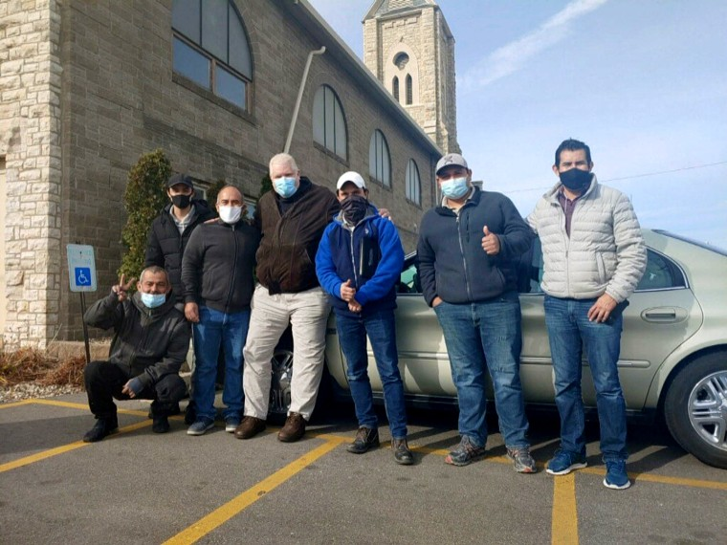
The six construction workers from Texas who stopped receiving pay for their work in Cedar Rapids, Iowa, flank the Rev. John Greve, pastor of Grace Episcopal Church, who fed and housed them after he learned about their situation.John Greve

BluSky, founded 16 years ago, is a leader in the growing business of restoring damaged buildings after extreme weather events or other disasters, with 800 employees in 36 locations nationwide. It said it completed 37,000 projects in 44 states last year.
One was in Minneapolis, where BluSky was hired to reconstruct buildings damaged during the protests last year over the police killing of George Floyd. The work the company performed is under scrutiny by the city's labor standards enforcement unit, according to people familiar with the matter and correspondence reviewed by NBC News. Asked about the inquiry, Brian Walsh, the city's director of labor standards enforcement and contract compliance, declined to comment.
Like many other companies in the burgeoning field, BluSky hires subcontractors to provide workers for the jobs. It pays subcontractors a set amount, and they, in turn, pay the workers.
BluSky is majority-owned by a New York-based private-equity company, Dominus Capital, which didn't respond to repeated requests for comment.
Private-equity firms buy companies, often using debt to finance the purchases, and hope to sell them later at a profit. As billions of dollars have poured into disaster recovery programs in recent years, private-equity firms have bought up restoration contractors positioned to profit.
BluSky says the workers who complete its jobs — typically wearing BluSky T-shirts — are not its employees but are those of subcontractors. For example, in November, when the Cedar Rapids incident arose, the firm sent a memo to its investors saying it had "no legal responsibility" to pay the workers because it had fully paid its subcontractor, Pablo Ramirez.
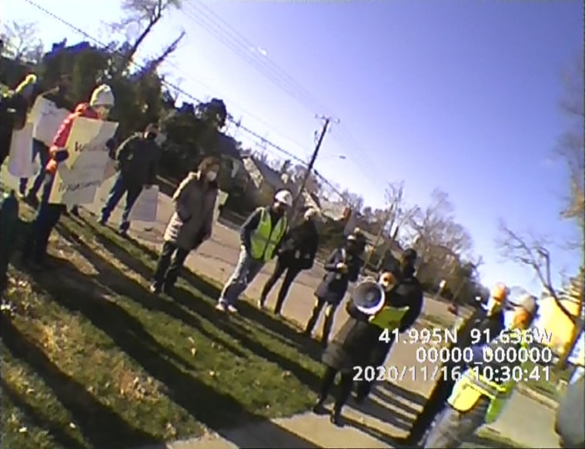
After weeks of no pay for BluSky's workers, protesters gathered at the Cedar Rapids worksite in November to urge the company to pay them.Royce Peterson
The use of subcontractors gives companies that don't pay workers plausible deniability for worker abuse, nonpayment of taxes and other improprieties that may occur on a job, Clark-Bennett said. And in interviews, Ramirez disputed BluSky's contention that it had paid him in full.
BluSky is also defending a 2019 lawsuit seeking class-action status in Minnesota brought by workers. They contend that BluSky and an intermediary, Labor Source LLC, fabricated time sheets depressing workers' pay, improperly deducted expenses from their wages and forced four to six workers to stay in hotel rooms with only two double beds. BluSky, which denied the allegations in court filings, lost its bid to dismiss the case.
A BluSky spokesman said in a statement that the company is committed to "ensuring that everyone who works on a BluSky project is paid fairly, accurately, and on time" and that the controversies in Iowa and Minnesota occurred without its knowledge.
"BluSky requires its subcontractors to follow all federal, state, and local wage and employment laws," the spokesman said. "In the exceptionally rare case where our policies are not followed, including the situations in Iowa and Minnesota, BluSky will — and has — taken action, which can include paying a subcontractor's employees directly, terminating a subcontractor, or other punitive actions."
NBC News contacted the intermediaries BluSky hired in both the Minneapolis investigation and the Minnesota lawsuit. An attorney for American Remediation Group, the staffing company hired for last year's job after the George Floyd protests, said the company had mistakenly underpaid 112 workers by about $1,400 in total. It told Minneapolis officials it would pay the workers to close the matter, but the city declined the offer, the lawyer said.
An attorney for Labor Source, the intermediary BluSky hired in the 2019 Minnesota suit, said in a statement: "Labor Source complies with all applicable wage and hour laws. We only work with contractors who do the same."
Three days after NBC News contacted BluSky for this article, it announced that it was expanding "its existing oversight programs to ensure that its trade partners pass a stringent vetting process, are keeping their workers safe, and are paying them fairly, accurately, and on time." In late July, the company announced a new code of ethics that contractors must sign. One requirement is that workers are "compensated in accordance with all applicable wage and work hour laws."

'Everything is my fault'

The problem of wage theft is national and common in underground economies where workers are at risk, said Summer Stephan, the district attorney for San Diego County. In February, Stephan formed a unit to prosecute criminal wage theft cases, staffed by a dedicated prosecutor and investigator.
"Wage theft affects the whole community's dignity, affects the state of our economy, and many, many people are hurt by it," Stephan said.
Local economies are hurt by the practice because employers paying cash to workers may not pay local taxes, reducing revenues for cities and towns. Research published by the Midwest Economic Policy Institute in January concluded that wage theft in the construction industry affects about 1 in 5 workers in Wisconsin, Minnesota and Illinois. The annual cost to taxpayers in those states exceeds $362 million.
Daniel J. Galvin, an associate professor of political science at Northwestern University, said Latino and Black workers are far more likely to be paid below minimum wage than their white counterparts and found that from 2009 to 2019, the lowest-paid workers nationwide lost 21 percent of their incomes because they were paid less than their states' minimum wages.
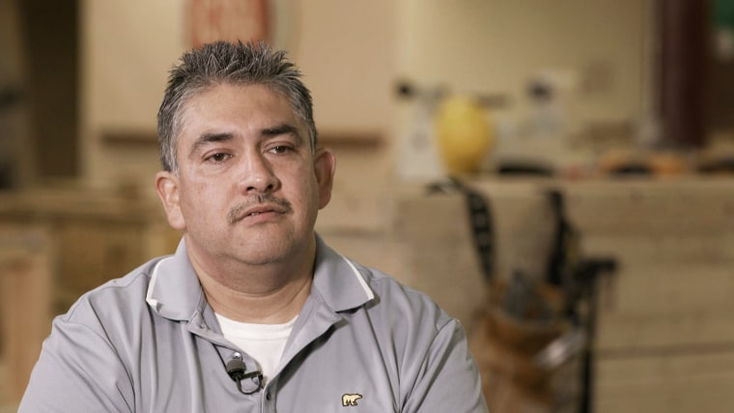
BluSky hired Pablo Ramirez, who owns a Dallas-based construction contracting company, as a contractor on the Cedar Rapids job.NBC News
Employers who violate minimum wage or overtime pay requirements are subject to civil penalties of up to $1,000 for each violation, according to the Labor Department. During the Trump administration, the department's Wage and Hour Division allowed employers to self-report violations of minimum wage and overtime and barred workers from bringing private actions against violators. The Biden administration rescinded the program of self-reporting in January.
The Fair Labor Standards Act protects workers from wage violations regardless of immigration status, but the scope of the government's enforcement effort has stagnated even as the size of the covered workforce has skyrocketed. In 2016, Galvin published research showing that in 1948, 1,000 federal investigators protected 22.6 million workers from wage violations under the law. By 2014, the investigators numbered 1,100, even though the workforce had increased sixfold, to 135 million. Today, 765 federal investigators police the covered workforce of 143 million.
Wage theft can reduce employers' costs significantly, said Clark-Bennett, who in addition to her job at the University of Iowa is a founding board member of the Center for Worker Justice of Eastern Iowa. On the Cedar Rapids job, for example, the pay initially promised to each worker worked out to about $15 an hour in cash, she said.
Union workers doing similar work in Cedar Rapids get $50 an hour, including benefits, said Burt Johnson, general counsel of the North Central States Regional Council of Carpenters, a labor union. BluSky is "inviting people in who can refer off-the-books labor and bring the underground economy in as a way to lower their bids," he said.
Asked to respond to the allegation, BluSky said through its spokesman that it has "always maintained an unwavering commitment to integrity and ethical business practices."
BluSky hired Ramirez, the owner of a construction contracting company in Dallas, as contractor on the Cedar Rapids job. In interviews, Ramirez said he worked on eight projects for BluSky last year, in places like Williston, North Dakota, and Kansas City and St. Joseph, Missouri. In each case, BluSky agreed to pay him a flat rate to complete a job, he said.
Ramirez never got all he was owed for those jobs, he said. He said the BluSky executive he worked with told him that he owed the company money, not the other way around. "He told me everything is my fault," Ramirez said.
BluSky's spokesman said a review of every project in which Ramirez was involved showed that the company paid him in full or more than he was owed. The spokesman said BluSky wasn't going to pursue Ramirez for what it said it overpaid him.
A subcontractor for another disaster restoration company, Cotton Commercial USA, told a similar story. The man, Reinaldo Quintero Ramirez (no relation to Pablo Ramirez), said that after Hurricane Irma damaged two hotels in the Florida Keys in 2017, he was hired to help Cotton, based in Houston, recruit workers to rebuild.
Reinaldo Ramirez said he and about 100 workers didn't receive full payment for their work. When workers confronted Cotton, he said, a company official told them that it wasn't responsible and that the staffing company it had hired as middleman was.
Ramirez disagreed. He said both the staffing company and Cotton are responsible. "The two companies are collectively responsible, because in the end, we work for both companies," he said. "One receives orders from Cotton supervisors. One does a good job for Cotton."
Eighteen workers sued Cotton and the staffing company, Superior Staffing & Payroll Services, for back pay. Although Cotton said it hadn't hired the workers, it agreed to pay them $50,000 last year.
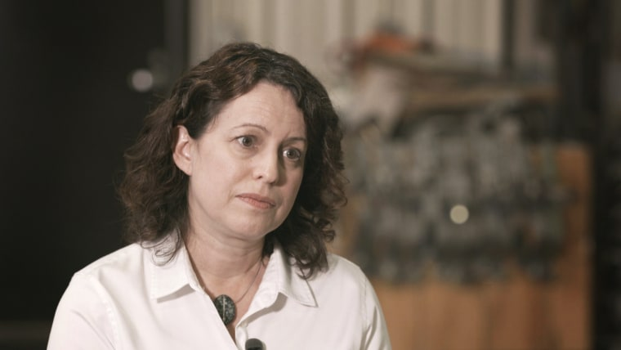
Robin Clark-Bennett, a labor educator at the University of Iowa Labor Center in Iowa City, helped the men negotiate for their pay.NBC News
Cotton made no admission of liability. Superior Staffing's owner, Daniel Paz,​​ who made no appearance in the case, ​hung up when NBC News sought comment.
A Cotton spokeswoman said in a statement, "Every Cotton contract includes provisions on subcontractors' responsibility for payment to their personnel in accordance with all applicable employment laws and regulations." In addition, she said, Cotton has documentation that it fully paid the staffing company for the work in the Florida Keys. "Cotton decided to effectively pay the labor twice with the settlement to uphold its reputation in the market when those who were responsible for payment disappeared," she said.
Sun Capital, a private-equity firm that bought Cotton in January 2020, declined to comment.
Private-equity firms are attracted by billions of dollars in public money and insurance funds spent to remediate natural disasters, said Saket Soni, executive director of Resilience Force, a nonprofit organization that advocates for restoration workers.
"After Hurricane Katrina, hedge funds and private-equity holding companies were coming into the disaster restoration and repair and recovery space in a huge way," Soni said. "They realized there were profits to be made."
The private-equity firm HarbourVest Partners of Boston owns a minority stake in BluSky. Asked about the accusations against the company, a HarbourVest spokesman said in a statement that Dominus, the private-equity firm that owns the majority of BluSky, had assured HarbourVest that actions were taken to address the wage theft allegations. "We have urged Dominus and BluSky to adopt a supplier code of conduct to ensure these incidents do not happen again," he said.
Paradoxically, investors in private-equity funds often include public pensions whose beneficiaries are retired laborers themselves. For example, the North Central States Regional Council of Carpenters' pension fund holds an investment in HarbourVest.
Johnson, the union's general counsel, is a trustee of its $1 billion pension fund. He characterized HarbourVest's response to the BluSky matter as "wholly inadequate."
"Private equity presents additional challenges because of the lack of transparency," he said. "HarbourVest failed to identify risks, and my job as a trustee is to hold them accountable."

'It's hard to look away'

Cold, hungry, miles from home and with no money for gas or food, the Cedar Rapids workers were desperate just weeks after they'd arrived, recalled one of them, Marco Antonio Maldonado Urbina. "It was very, very hard, because we needed to send money to our families in Houston," he said in a phone interview.
They found help from an unexpected source: the local carpenters union.
"The first thing that set us back was they told us they hadn't been paid in weeks and had very minimal food," said Royce Peterson, lead representative for the North Central States Regional Council of Carpenters. "We decided to take a delegation into the job site to demand they pay these people."
Coordinating with a local food pantry, Peterson reached out to area pastors and local officials to find a place for the men to sleep. They moved into Grace Episcopal Church, and its rector, the Rev. John Greve, a former chef, cooked for them. "It was an easy call," Greve said. "We have encountered this before, but this was a particularly bad instance, where living quarters, food, everything was being denied these guys."
The BluSky spokesman said in a statement: "As soon as BluSky learned about the complaints, to ensure Mr. Ramirez's workers were paid, BluSky stepped in and paid Mr. Ramirez's employees directly."
But Peterson, who was involved in all the back and forth, disputed that timeline. He said it was only after local media picked up the story that two BluSky executives, Chief Operating Officer Mike Erekson and Vice President Eric Helgemoe, flew to Cedar Rapids to address the controversy. Even then, the executives denied during early talks that the workers were their employees, Peterson said. Helgemoe stepped on his own message when he said hello to a worker in the group whom he'd recently employed for a private renovation job at his home in Kansas City, Peterson said.
Finally, in a meeting with the workers and their local supporters, Erekson agreed to pay the men $35,000, said Clark-Bennett, a participant. But the money would be paid, the company said, only after the workers signed agreements barring them from talking to the media. Then the executives left town.
Galvin, the Northwestern professor, said wage theft is a persistent problem that requires changes to the country's labor laws. Devised in the 1930s, the laws don't cover domestic and farm workers, independent contractors and public-sector employees.
Workers are "trying to recover some sort of protections and rights in the workplace where they have virtually none," Galvin said. "Once you realize the extent of the problem, it's hard to look away."

